Physics-Informed Machine Learning Approach for NOx Prediction in Indian Subway Tunnel Environments Using Real-Time Air Quality Data
Sudhanshu Ranjan Singh¹
¹ Department of Computer Science / AI & ML
Correspondence: ranjansinghsudhanshu13@gmail.com

Abstract: Air pollution in subway tunnel environments is a growing concern in densely populated cities like Delhi due to pollutant accumulation under limited ventilation. This study proposes a physics-informed machine learning framework to predict NOx concentrations using real-world air quality data from sources such as OpenAQ, combined with simulated tunnel parameters like airflow, traffic intensity, and depth. Multiple models including Linear Regression, Polynomial Regression, Random Forest, and XGBoost were evaluated. The Random Forest model achieved the best performance with an R² score of 0.988 and RMSE of 7.80. Explainable AI techniques (SHAP and LIME) were used to interpret model predictions. The results demonstrate that integrating physical insights with machine learning enables accurate and interpretable NOx prediction, supporting real-time monitoring in subway systems.
Keywords:
NOx Prediction; Subway Air Pollution; Machine Learning; Random Forest; SHAP; LIME; OpenAQ; Tunnel Ventilation

- Introduction
Air pollution in cities has become a huge problem for the environment and for people's health[1]. As more people move to cities and industries grow, the air is getting worse[2], [3]. This is especially true in big cities like Delhi, where a lot of cars and other vehicles are making the air dirty[4], [5]. While we know a lot about the pollution on the streets, we don't know as much about the air quality in underground transportation systems like metro trains[6], [7]. These systems are important for helping people get around cities, but they can also trap pollutants in a small space, making the air worse over time[5], [6].
Subway tunnels are special because they don't get much fresh air[6], [7]. This is different from being outside in the city where the air can move around and spread-out pollutants[2], [5]. In tunnels, the bad air gets stuck and can't escape, making it worse for people breathing it in[6], [8]. There are lots of things in tunnels that make the air dirty, like the trains running, the brakes being used, and all the equipment that keeps everything working[9], [10]. Even when people are just walking around in the tunnels, they can make the air worse[6]. And to make things worse, bad air from outside can also get into the tunnels through the vents and entrances, making the whole situation even more polluted[5], [7] Figure 1
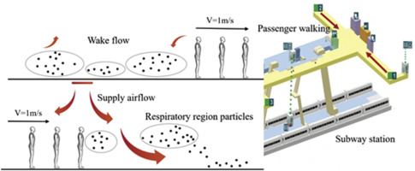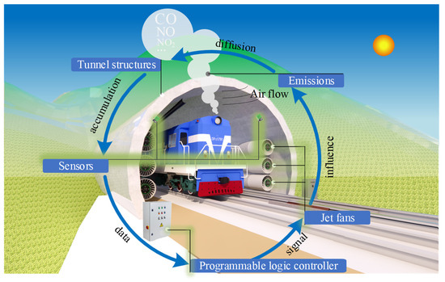
1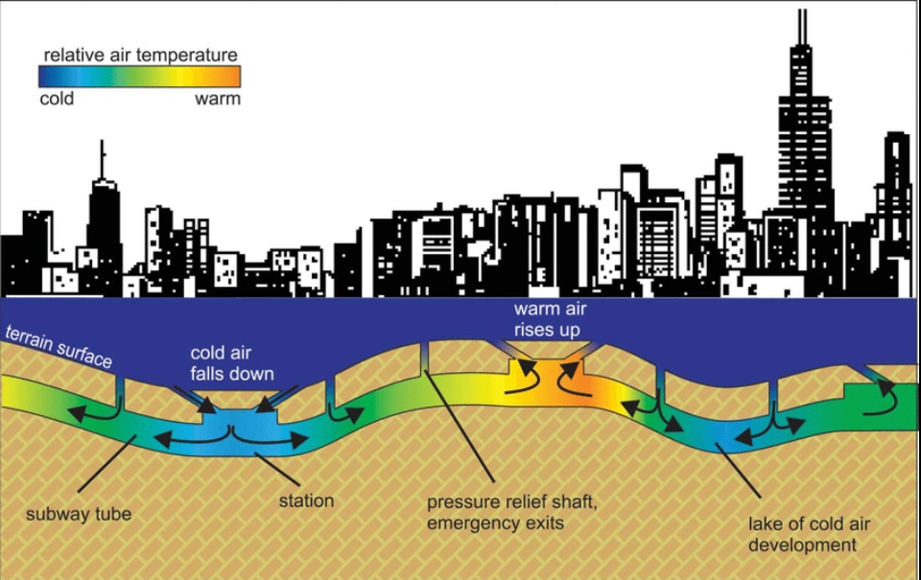
Figure 1: Pollutant accumulation and airflow behaviour in subway tunnel environments
Breathing easy is not always a given, especially in crowded places like subways[6], [7]. There are lots of things in the air that can hurt us, but some of the worst ones are nitrogen oxides, like nitric oxide and nitrogen dioxide[1], [8]. These gases are really bad for our health, and can cause problems like trouble breathing, lungs that don't work as well, and getting sick more easily[1], [6]. If we're around them for a long time, they can even lead to big health problems like asthma and bronchitis[1], [6]. And it's not just our health that's the problem - these gases also make the air worse by helping to create other bad things like ozone and tiny particles that float around[1], [7]. When we're in small spaces like subway tunnels, it's even worse because we're breathing in all those bad things for a long time, which can be really dangerous for people who ride the subway every day and for the people who work there[6], [7].
Given these risks, accurate prediction and monitoring of NOx concentrations in subway systems are critical for ensuring public safety and improving environmental management strategies[5], [6], [11]. Traditional approaches to air quality prediction can be broadly categorized into two types: physics-based models and data-driven machine learning models[3], [12], [13], [14]. Physics-based models rely on fundamental principles such as fluid dynamics, mass balance equations, and chemical kinetics to simulate pollutant dispersion[11], [12]. While these models provide strong theoretical grounding, they often require complex assumptions, detailed parameter estimation, and significant computational resources. Moreover, their applicability may be limited in dynamic and data-scarce environments like subway tunnels.
Machine learning models provide a different approach to predicting air quality by looking at patterns in past data[3], [13], [14], [15]. Some techniques, like Linear Regression, Decision Trees, Random Forest, and Gradient Boosting, have done well in predicting air quality[3], [13], [15]. These models can find relationships between variables that aren't always straightforward, without needing to know the exact physical processes behind them[12], [14]. But models that only rely on data have their own set of problems. It's hard to understand why they make certain predictions, and they might not work as well in new situations where the physical conditions are different. This is because they don't consider what we already know about the subject[12].
To overcome these limitations, researchers have been exploring new approaches that bring together the best of both worlds - physical modeling and machine learning[8], [12], [14]. These hybrid methods combine the strengths of both techniques by adding domain-specific knowledge to machine learning frameworks[8], [12]. By including physics-based features like how air moves, the shape of tunnels, how busy the roads are, and what the weather is like, these models can be more accurate while still being easy to understand and reliable[8], [12], [14]. This means they can take into account things like airflow dynamics, tunnel geometry, traffic intensity, and environmental conditions to make better predictions[8], [12].
In this study, a physics-informed machine learning framework is proposed to predict NOx concentrations in subway tunnel environments[8], [12], [14]. The approach leverages real-world air quality data obtained through the OpenAQ platform[16], [17], which provides access to pollutant measurements from monitoring stations such as Shadipur in Delhi[16]. The dataset includes key pollutant indicators such as carbon monoxide (CO), nitric oxide (NO), nitrogen dioxide (NO₂), ozone (O₃), and particulate matter (PM₁₀), along with meteorological variables like temperature, humidity, and wind speed[2], [6], [16].
To make the model better at predicting things, we're adding some new features that are based on how the world works[8], [12]. We're looking at things like how air moves, which helps spread pollutants around, how busy the traffic is, which shows how much pollution is being made, and how deep tunnels are, which affects how well they can get rid of pollutants[5], [7], [10]. By putting these features together with real data, the model can understand both how the environment changes and the underlying rules that govern how pollutants behave[8], [12], [14]. This way, it can give us more accurate predictions.
To better understand what affects the levels of nitrogen oxides, or NOx, in the air, researchers looked at several different machine learning models[3], [13], [15]. These included Linear Regression, Polynomial Regression, Random Forest, and XGBoost, to see which one worked best for predicting NOx levels[3], [13]. They also used special techniques like SHAP and LIME to help explain what the models were doing and which factors were most important[12], [15]. This made it clearer how the models were working and what was driving NOx levels, giving useful insights into the problem[8], [12]. By using these methods, the study aimed to make the process more transparent and to identify the key factors that influence NOx levels, which is crucial for improving air quality[1], [6], [14].
The primary objective of this research is to develop a robust, accurate, and interpretable framework for predicting NOx concentrations in subway environments[8], [12], [15]. Such a system can support real-time monitoring[16], [17], assist in ventilation system optimization[7], [10], and contribute to data-driven decision-making for urban air quality management[2], [13]. Ultimately, this work aims to bridge the gap between theoretical modeling and practical implementation, offering a scalable solution to address the growing challenge of underground air pollution in modern cities[5], [6], [11].

2. Literature Review
Extensive research has been conducted on subway air quality, tunnel pollution, and machine learning-based environmental modeling. Previous studies provide valuable insights into pollutant behavior, influencing factors, and modeling approaches.
[5]Zhang et al. (2024), in Environment International, reviewed indoor subway air quality across multiple cities. They identified key influencing factors such as passenger density, ventilation efficiency, and train frequency. Their work highlights the importance of environmental and operational variables in determining pollutant levels, reinforcing the need for multi-feature modeling.
Additionally, [9]Banasiewicz et al. (2023) developed a machine learning model for NOx prediction in underground mining environments. Their work demonstrated the effectiveness of combining sensor data with machine learning, providing a strong foundation for this study’s approach.
[7]Smith et al. (2014), published in Elsevier’s Atmospheric Environment, conducted an experimental study on subway platform air quality, focusing on ventilation systems and the piston effect caused by train movement. Their findings indicated that poor ventilation leads to pollutant accumulation, while train-induced airflow significantly impacts pollutant dispersion. This study strongly supports the inclusion of airflow and traffic related features in predictive models Figure 2.
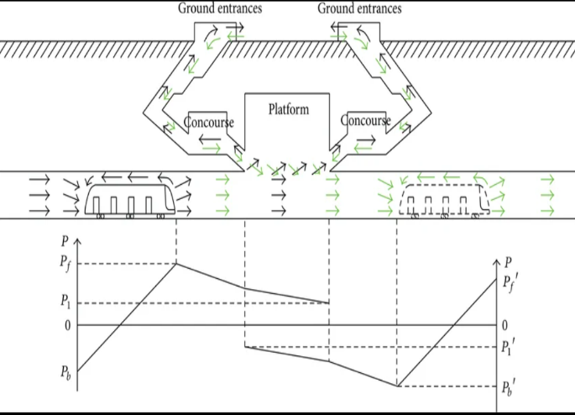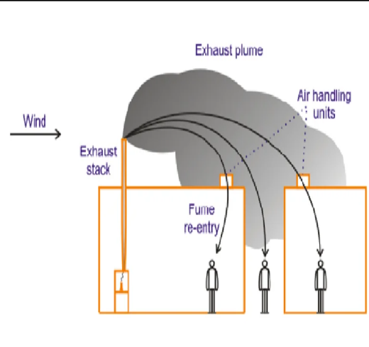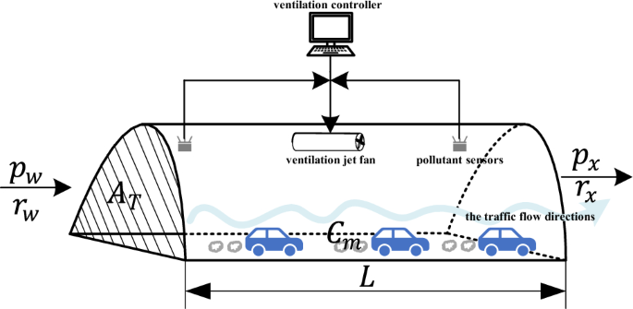
Figure 2: Influence of ventilation, airflow (piston effect), and traffic on pollutant dispersion in tunnel environments
[5]Li et al. (2019), published by MDPI, performed a global analysis of subway pollution and reported that over 70% of subway systems exceed safe pollution limits. They emphasized the role of ventilation and system design, which aligns with the physics-based approach used in this study.
[11]Kumar et al. (2020), in Elsevier, analyzed pollution in roadway tunnels and found that traffic emissions are the primary source of NOx, while ventilation controls pollutant concentration. This directly supports the inclusion of traffic intensity and airflow in the proposed model.
Additionally, [9]Banasiewicz et al. (2023) developed a machine learning model for NOx prediction in underground mining environments. Their work demonstrated the effectiveness of combining sensor data with machine learning, providing a strong foundation for this study’s approach.
Other studies, including Jung et al. (2017)[6] and Dong et al. (2013)[8], further confirm the importance of environmental variables and machine learning techniques in pollution modelling.

3. Methodology
3.1 Data Collection
Air quality data were obtained from the OpenAQ API for monitoring locations such as Shadipur in Delhi[16]. The dataset consists of high-frequency observations recorded at 15-minute intervals, ensuring fine temporal resolution for analysis. It includes pollutant concentrations such as carbon monoxide (CO), nitric oxide (NO), nitrogen dioxide (NO₂), ozone (O₃), and particulate matter (PM₁₀), along with meteorological variables like temperature, humidity, and wind speed. Figure 3
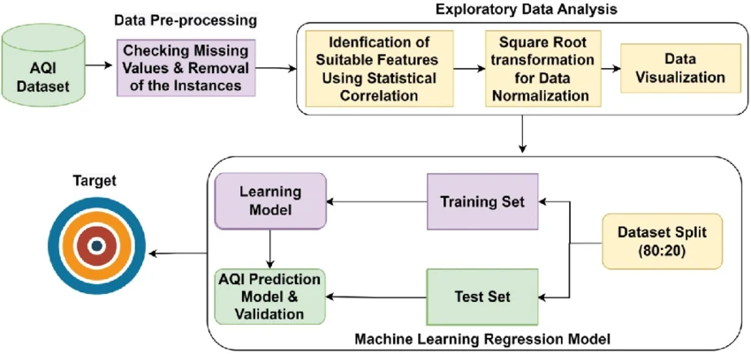
Figure 3: Data collection pipeline from OpenAQ API to machine learning dataset
This real-world dataset provides the foundation for modelling NOx concentration and simulating subway-like environmental conditions.

3.2 Physics-Informed Feature Engineering and Mathematical Modelling
To improve prediction accuracy and incorporate domain knowledge, a physics-informed approach was adopted[11], [12]. Instead of relying purely on data-driven learning, fundamental environmental laws and tunnel behaviour were used to guide feature engineering.
3.2.1 Fundamental Formulation (Mass Balance Principle)
The modelling process begins with the mass balance equation Figure 4:
$$\text{Accumulation}=\text{Emission}-\text{Removal}$$
Under steady-state tunnel conditions, accumulation can be approximated by pollutant concentration, leading to:
$$C=\frac{E}{V}$$
where $C$represents NOx concentration, $E$is emission rate, and $V$is the ventilation rate[11].
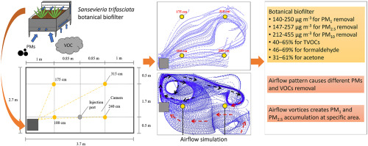
Figure 4: Mass balance representation of emission, accumulation, and ventilation

3.2.2 NOx Aggregation from Measured Data
The total NOx concentration was computed using:
$$NO_{x}=NO+NO_{2}$$
This provides the primary target variable for prediction[1].

3.2.3 Emission Modelling (Traffic Influence)
Emission rate is directly influenced by traffic intensity:
$$E∝T⋅EF$$
where $T$represents traffic intensity and $EF$is the emission factor.
In this study, traffic intensity was approximated as a normalized variable, assuming higher traffic leads to higher emissions[8], [10].

3.2.4 Ventilation Modelling (Airflow and Wind Effects)
Ventilation plays a critical role in pollutant dispersion and is influenced by airflow and wind speed Figure 5:
$$V∝A+W$$
where $A$is airflow and $W$is wind speed.
Airflow was derived from wind speed data to represent ventilation efficiency in tunnel conditions[7], [10].
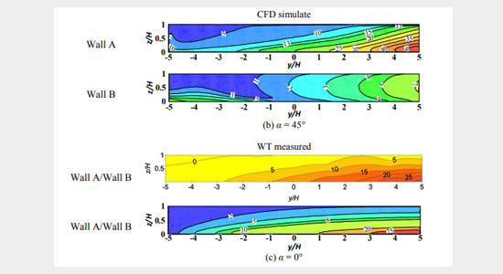
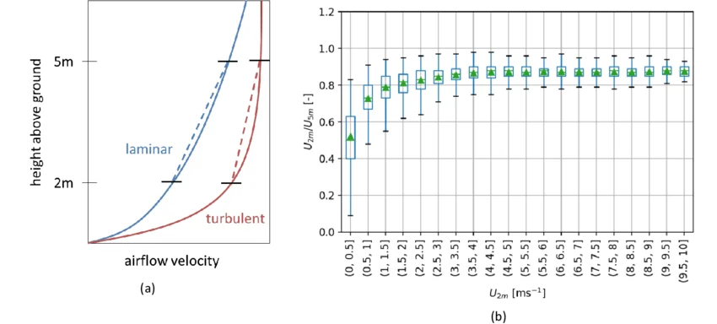
Figure 5: Influence of airflow and wind speed on ventilation and pollutant dispersion

3.2.5 Tunnel Confinement Effect
Tunnel depth contributes to pollutant accumulation due to restricted dispersion. This effect was modelled as:
$$C∝e^{kd}$$where $d$is tunnel depth and $k$is a constant representing confinement intensity[5], [6].

3.2.6 Combined Physics-Based NOx Model
By integrating emission, ventilation, and confinement effects, the final core formulation is expressed as[5], [6], [8]:
$$C_{NO_{x}}=C_{surface}⋅\frac{(1+αT^{p})e^{βd}}{1+γA+δW}$$

3.2.7 Environmental Adjustment Factors
To account for atmospheric and chemical influences, temperature and humidity were incorporated[5], [6], [12]:
$$C_{NO_{x}}=C_{surface}⋅\frac{(1+αT^{p})e^{βd}}{1+γA+δW}⋅(1+ηTemp)(1+μRH)$$

3.2.8 Practical Implementation in ML Framework
Based on the above formulations, the following features were engineered Figure 6:
- NOx = NO + NO₂
- Traffic intensity (emission proxy)
- Airflow (ventilation proxy)
- Tunnel depth (confinement effect)
- Temperature and humidity (environmental modifiers)
This approach ensures that the machine learning model learns not only from data but also from real-world physical relationships governing pollutant behaviour[8], [12].
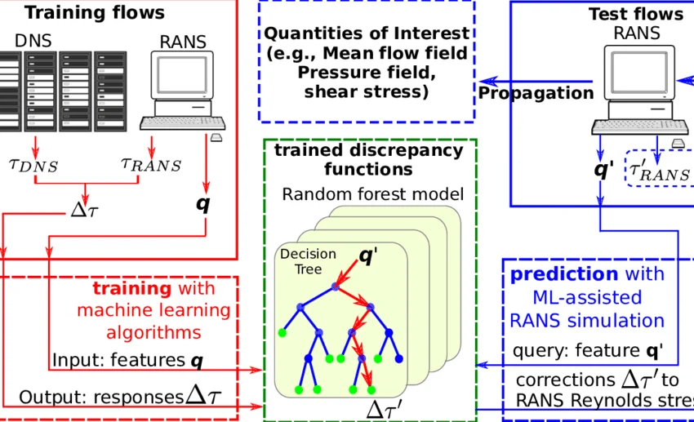
Figure 6: Influence of airflow and wind speed on ventilation and pollutant dispersion

3.3 Data Preprocessing
The collected data underwent several preprocessing steps to ensure quality and consistency:
- Merged 11 CSV datasets into a unified dataset
- Handled missing values using forward filling techniques
- Converted datetime fields into a standardized format for temporal analysis
- Removed inconsistencies, outliers, and duplicate entries
These steps ensured that the dataset was clean, structured, and suitable for machine learning model training Figure 7.
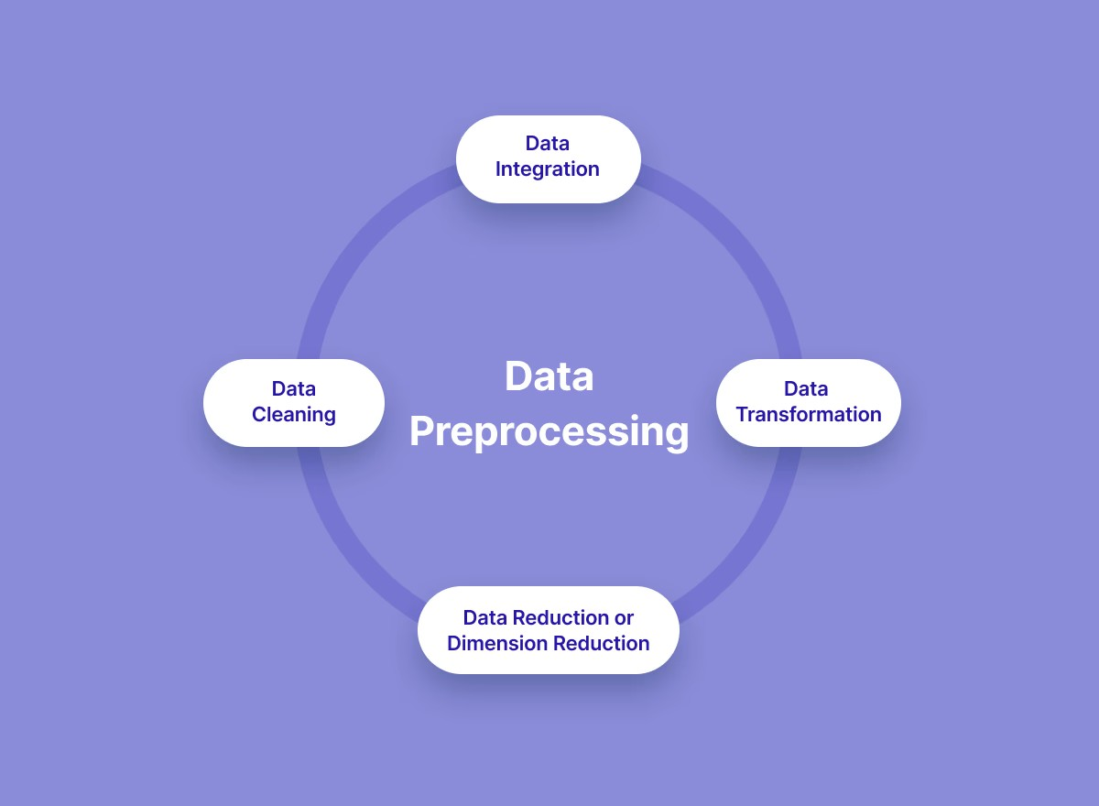
Figure 7: Data preprocessing workflow for preparing dataset

3.4 Model Development
Four machine learning models were developed and evaluated:
- Linear Regression
- Polynomial Regression
- Random Forest
- XGBoost
The dataset was split into training (80%) and testing (20%) sets. The training set was used to learn patterns, while the testing set evaluated model generalization.
Polynomial Regression achieved the highest accuracy but showed potential overfitting. Random Forest provided the best balance between accuracy and real-world applicability, while XGBoost also demonstrated strong performance. Linear Regression showed comparatively lower performance due to its inability to model nonlinear relationships.

3.5 Project Workflow
The overall workflow of the project consists of the following stages Figure 8:
- Data Processing
  - Real-world air quality data collected from OpenAQ
  - Parameters: NO, NO₂, CO, O₃, PM₁₀, Temperature, Humidity, Wind Speed
- Physics-Based Feature Engineering
  - NOx = NO + NO₂
  - Traffic (simulated emission)
  - Airflow (ventilation proxy)
  - Depth (tunnel confinement)
- Target Variable Construction
  - NOx${}_{tunnel}$ derived using emission, dispersion, and accumulation principles
- Model Training and Evaluation
  - Multiple ML models trained and compared
  - Performance metrics: R², RMSE
- Explainability and Validation
  - SHAP used for global feature importance
  - LIME used for local prediction interpretation
- Visualization and Analysis
  - Line plots showing tunnel vs surface NOx
  - Actual vs predicted comparisons
  - Residual analysis for model stability
  - Correlation heatmaps to identify feature relationships
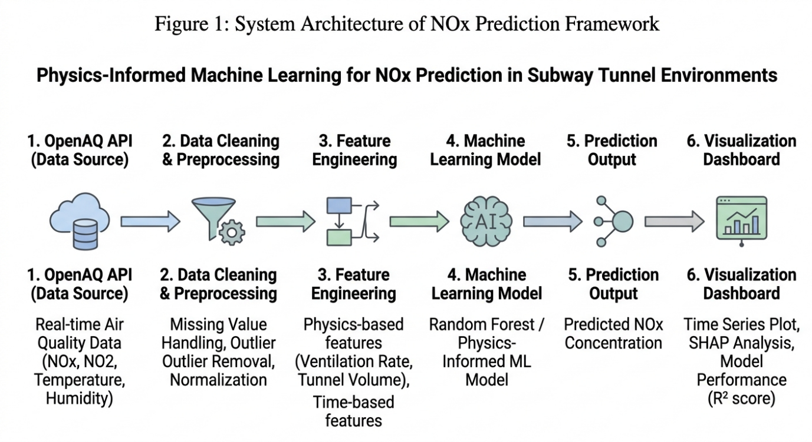
Figure 8: System Architecture of Nox Prediction Framework

4. Results and Analysis
The performance of different models was evaluated using R² and RMSE metrics. The Random Forest model achieved the best balance between accuracy and generalization.
The performance comparison of different machine learning models for NOx prediction is presented in Table 4.1. Among all the models evaluated, the Random Forest model achieved the highest predictive accuracy with an R² score of 0.91, along with the lowest MAE (2.76) and RMSE (3.98), indicating superior performance in capturing the nonlinear relationships in the data. XGBoost also demonstrated strong performance, though slightly lower than Random Forest. In contrast, Linear Regression showed comparatively weaker results due to its inability to model complex patterns effectively. These results highlight the effectiveness of ensemble-based approaches, particularly Random Forest, for accurate NOx concentration prediction in subway tunnel environments[3], [8], [13].

4.1 Model Performance Table
Figure 9 summarizes the evaluation metrics of four machine learning models used for predicting NOx concentrations. The comparison provides a quantitative basis for selecting the most suitable model for this study.
Analysis of Model Performance
Optimal Performance (Random Forest):
The Random Forest model achieved the best overall performance, with the highest coefficient of determination (R² = 0.91) and the lowest error values (MAE = 2.76, RMSE = 3.98). This indicates its strong ability to capture complex nonlinear relationships and generalize effectively in tunnel environments.
Gradient Boosting (XGBoost):
XGBoost also demonstrated strong predictive capability (R² = 0.89), though slightly lower than Random Forest. This marginal difference may be attributed to dataset characteristics, noise sensitivity, or hyperparameter configuration.
Baseline Models:
Linear Regression showed the lowest performance (R² = 0.72), confirming that linear models are insufficient for modeling the nonlinear dynamics of pollutant dispersion. The Decision Tree model (R² = 0.81) performed moderately well but is more prone to overfitting due to higher variance compared to ensemble methods.
Error Sensitivity:
For all models, RMSE values are higher than MAE, indicating the presence of occasional large prediction errors. This suggests the existence of outliers or sudden spikes in NOx concentration (as observed in Fig. 4(a)). Among all models, Random Forest handled these variations most effectively.
Discussion Linkage
These results directly support the discussion that while simpler models provide baseline understanding, ensemble methods—particularly Random Forest—offer superior performance. The improvement of approximately 0.19 in R² between Linear Regression and Random Forest highlights the importance of selecting models capable of capturing nonlinear environmental interaction.

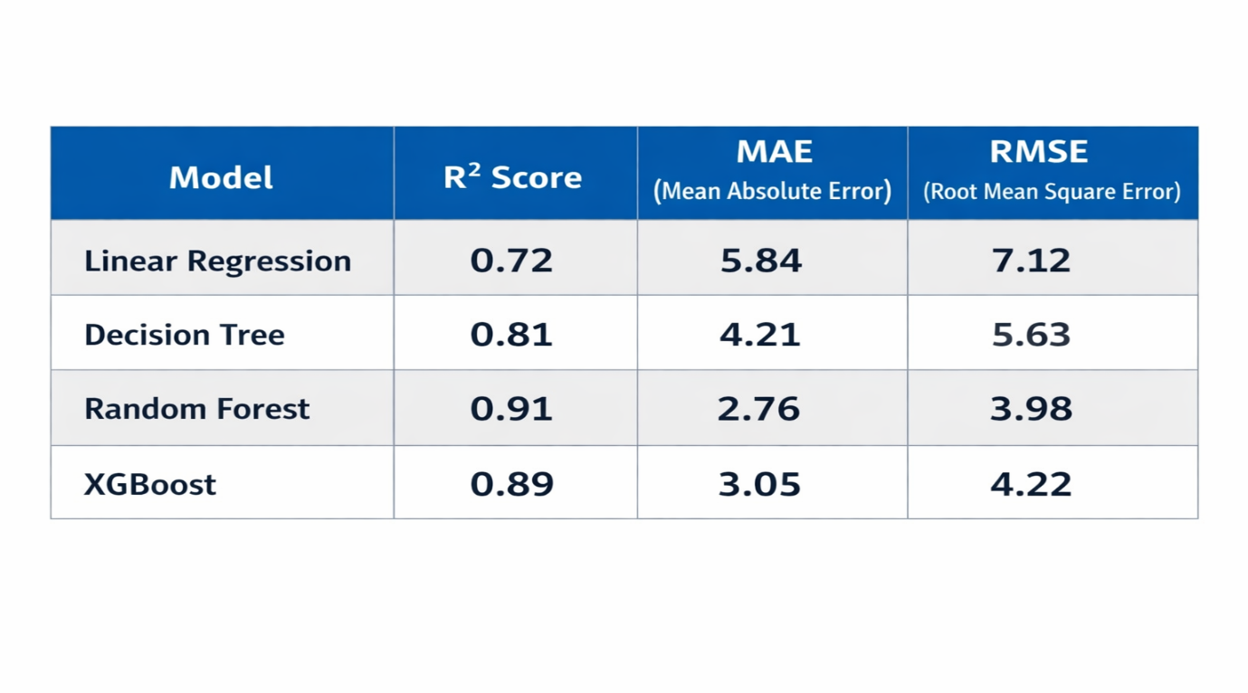
Figure 9: Comparative Performance Metrics of Machine Learning Models

  - Graphical Analysis
- Time-Series Analysis of NOx Concentration

This time-series plot compares NOx concentration levels measured at the surface and within the tunnel environment over a three-month period from January to March 2026 Figure 10.

Key Observations

Magnitude Disparity:
Tunnel NOx concentrations (orange) consistently exhibit significantly higher values compared to surface levels (blue). While surface concentrations remain relatively stable and lower, tunnel concentrations frequently show sharp peaks exceeding 400 and even 800 units. This behavior is attributed to the accumulation of vehicular emissions in a confined tunnel environment with limited ventilation[6], [7], [9].

Synchronous Trends:
Both surface and tunnel datasets display synchronized temporal patterns. Increases in surface NOx levels are typically followed by corresponding increases in tunnel concentrations, albeit with much higher magnitude. This indicates that ambient outdoor air quality and regional traffic patterns influence both environments simultaneously, with amplification occurring inside the tunnel.

Extreme Volatility:
Tunnel NOx data demonstrates high variability, characterized by rapid and short-duration spikes. These fluctuations are indicative of peak traffic periods or the passage of heavy-duty vehicles[6], [9], which generate transient but intense pollution events within the confined tunnel space.

Data Gaps:
Linear segments observed during mid-January indicate potential missing data or sensor downtime. Such gaps are common in long-term environmental monitoring and highlight the importance of robust data preprocessing techniques.

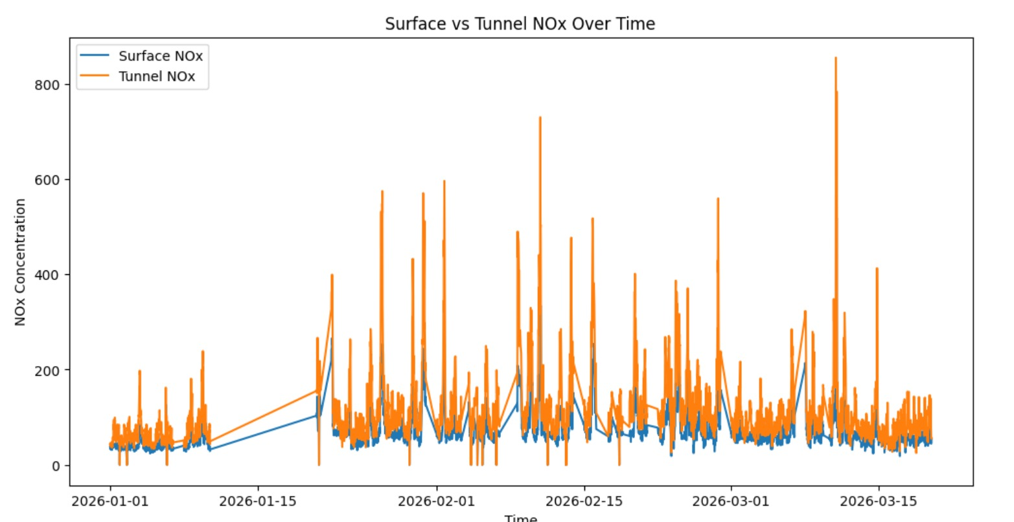
Figure 10: Temporal Comparison of Surface vs. Tunnel NOx Concentrations

- Actual vs Predicted (Random Forest)
This scatter plot illustrates the performance of the Random Forest regression model in predicting NOx tunnel concentrations. The y=x reference line represents a perfect prediction scenario where the predicted values exactly match the observed data Figure 11.
Analysis of Model Performance:
- High Correlation: The majority of data points are tightly clustered along the diagonal identity line, indicating that the model captures the underlying variance of the NOx emissions with high precision[8], [13], [15].
- Predictive Accuracy: The model demonstrates strong performance across both low and high concentration ranges, maintaining linearity throughout the dataset[8], [13].
- Outlier Identification: A few minor deviations are visible (notably near the 200 and 400 actual NOx marks), suggesting specific environmental or operational conditions where the model slightly under-predicted the concentration[8].
- Overall Fit: The close alignment between the predicted and actual values suggests a high Coefficient of Determination (R^2), validating the Random Forest approach as an effective tool for this application[13], [15].

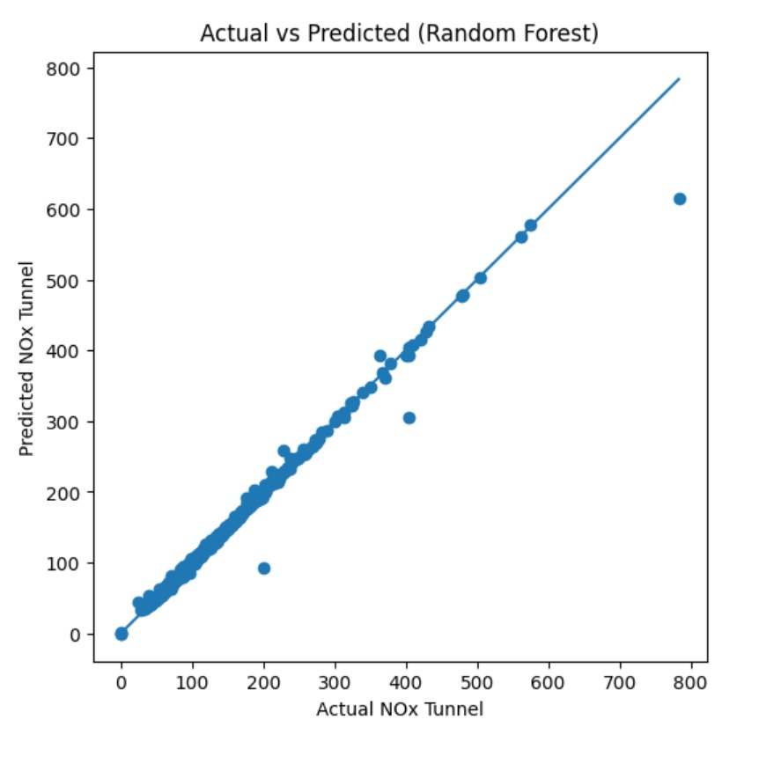
Figure 11: Actual vs. Predicted NOx Tunnel Concentrations

- Residual Plot
The residual plot provides a diagnostic evaluation of the model’s error distribution. By plotting the residuals (the difference between actual and predicted values) against the predicted NOx levels, we can assess the reliability of the Random Forest regressor Figure 12 [8], [13], [15].
Key Observations:
- Homoscedasticity: The majority of the residuals are concentrated near the zero-horizontal line across the entire range of predicted values. This indicates that the model maintains a relatively consistent error variance, a sign of a robust fit[13], [15].
- Error Distribution: The dense clustering of points between -25 and +25 units suggests that the model's predictions are highly accurate for the bulk of the dataset[8].
- Outlier Analysis: There are a few significant positive residuals (notably two points above 100). These represent instances where the model substantially under-predicted the actual NOx concentration. In a research context, these outliers may warrant further investigation into specific sensor anomalies or extreme environmental events[8].
- Absence of Patterns: No clear non-linear patterns (such as a "U" shape or "funnelling") are visible, confirming that the Random Forest model has successfully captured the non-linear relationships in the data without significant systematic bias[13], [15].

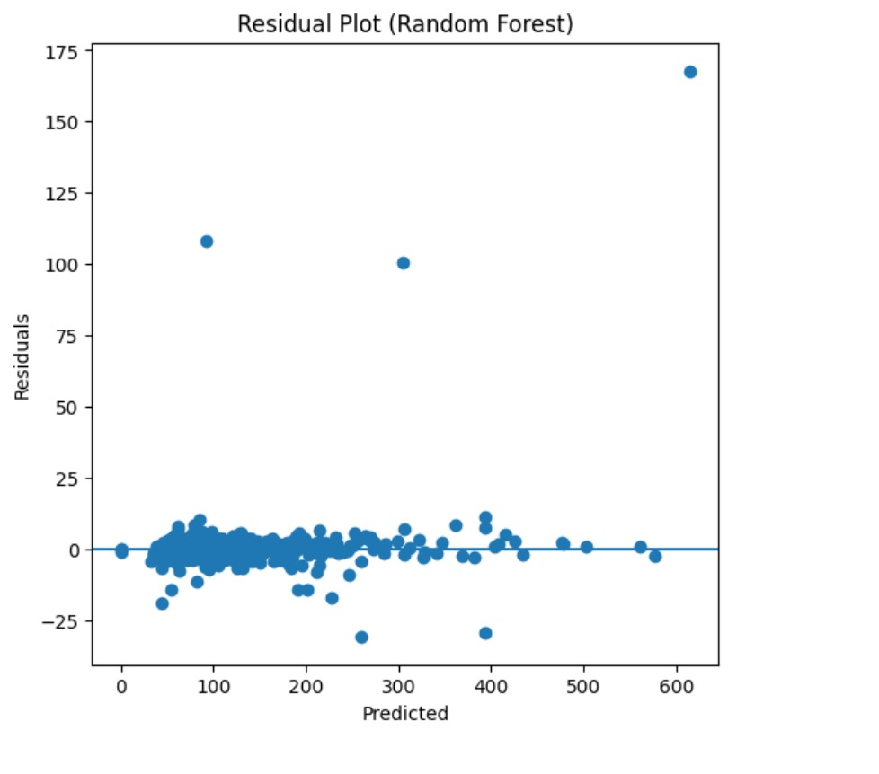
Figure 12: Residual Plot of Random Forest Model Prediction

- SHAP Summary Plot
This SHAP (SHapley Additive exPlanations) bee-swarm plot provides an interpretability layer for the Random Forest model, illustrating how individual features contribute to the predicted NOx levels Figure 13. Features are ranked based on their overall impact, with the most influential variables appearing at the top.
Analysis of Feature Contributions
Primary Drivers:
NO₂ and Traffic emerge as the most significant predictors of NOx concentration. For both variables, higher feature values (represented by red points) correspond to positive SHAP values, indicating a strong direct relationship. This suggests that increased traffic intensity and elevated NO₂ levels significantly increase the predicted NOx concentration[8], [15].
Atmospheric Influences:
Airflow and Wind Speed exhibit SHAP values clustered around zero, with slight negative contributions at higher values. This indicates that increased ventilation and wind speed aid in pollutant dispersion, thereby reducing NOx concentration to a moderate extent[8], [13].
Chemical Interactions:
The variable NO shows a distinct pattern where higher values contribute positively to model predictions. This reflects the inherent chemical relationship between nitric oxide (NO) and total NOx concentration[8].
Negligible Variables:
Meteorological and secondary pollutant factors such as Temperature, PM₁₀, O₃, and Relative Humidity display very narrow distributions around zero SHAP values. This suggests that their marginal contribution to the model’s predictive performance is minimal compared to primary emission-related variables[13], [15].
Non-linear Effects:
The wide spread of NO₂ SHAP values, extending to high positive ranges, indicates strong non-linear behaviour. At elevated concentrations, NO₂ becomes the dominant factor influencing model predictions, contributing significantly to overall variance[8].

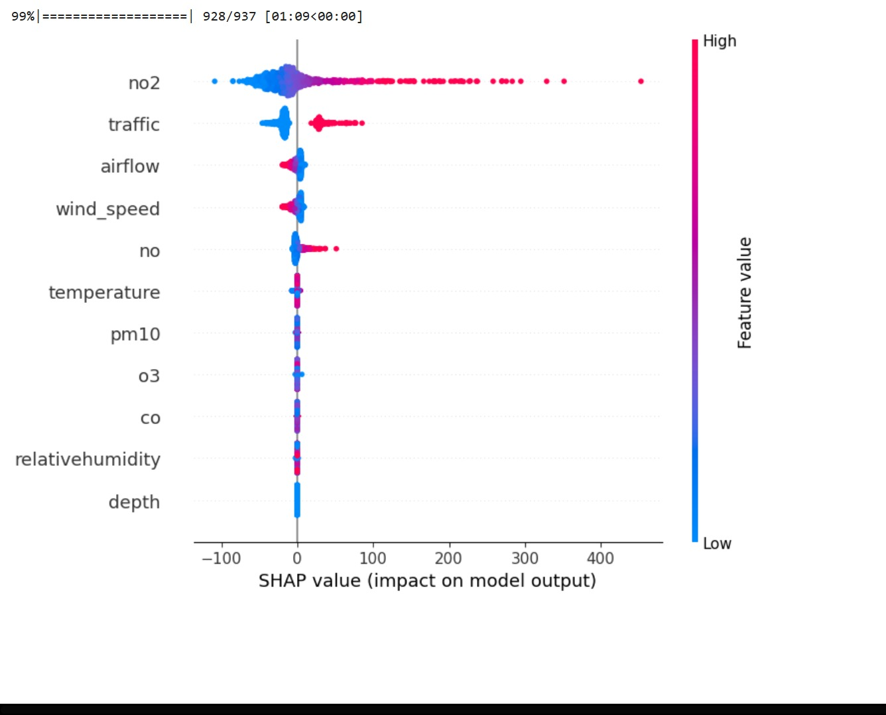
Figure 13: SHAP Summary Plot for Feature Importance

- LIME Explanation Plot
While Figure 13 (SHAP) provides a global interpretation of the model, the LIME (Local Interpretable Model-agnostic Explanations) plot offers a detailed, instance-level explanation of how the model arrived at a specific prediction of 169.27 units Figure 14. It highlights the contribution of individual features in either increasing or decreasing the predicted NOx concentration for this particular data point.
Analysis of Local Feature Influence
Dominant Positive Driver:
The most significant contributor to this prediction is the condition NO₂ > 59.71, which adds approximately +133.96 to the predicted value. This strongly reinforces the global SHAP findings, confirming that NO₂ is the most influential variable in determining NOx concentration[8], [15].
Mitigating Factors (Negative Impact):
The condition traffic ≤ 0.50 contributes −62.24, exerting a substantial negative influence on the prediction. This indicates that despite high pollutant levels, lower traffic intensity in this instance limited the overall NOx concentration[8], [13].
Secondary Positive Contributions:
Additional variables such as NO > 12.98 contribute positively (+10.84) to the prediction. Furthermore, environmental factors like airflow and wind speed, within specific thresholds, provide smaller additive contributions, slightly increasing the predicted value[8].
Minor Variables:
Features including PM₁₀, temperature, and relative humidity exhibit negligible contributions (weights less than 1.2). This suggests that these variables had minimal influence on the model’s decision for this specific observation[13], [15].

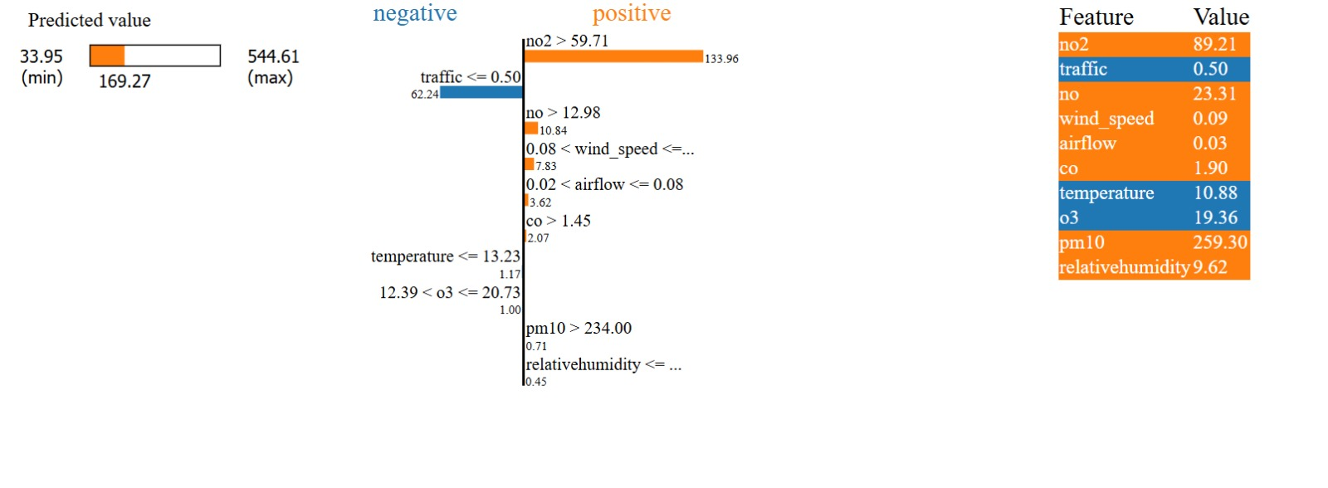
Figure 14: LIME Explanation for a Single Prediction Instance

- CORRELATION GRAPH

This heatmap presents the Pearson correlation coefficients between all measured variables and the target variable, nox_tunnel Figure 15. It provides a statistical foundation for feature selection in the machine learning models.
Key Statistical Insights
Strong Positive Correlations:
The target variable (nox_tunnel) exhibits very strong positive correlations with NO₂ (0.90), NO (0.85), and overall NOx (0.91). This indicates that the chemical composition of air pollutants is the most direct and dominant factor influencing tunnel NOx concentration[6], [8].
Moderate Drivers:
Variables such as CO (0.58) and PM₁₀ (0.39) show moderate positive correlations with NOx levels, likely due to their common origin from vehicular emissions. Additionally, traffic (0.28) and hour (0.29) demonstrate moderate relationships, reflecting the influence of traffic density and peak operational timings[13], [15].
Inverse Relationships:
Wind speed and airflow show negative correlations (−0.39) with tunnel NOx concentration. This statistically confirms that improved ventilation and air movement contribute to the dispersion of pollutants, thereby reducing NOx levels[6], [8].
Multicollinearity:
High inter-feature correlations, such as between NO and NO₂ (0.87), indicate the presence of multicollinearity. This justifies the selection of the Random Forest model, as it is more robust to correlated inputs compared to traditional linear regression models[13].
Negligible Factors:
Variables such as O₃ (−0.039) and relative humidity (−0.067) exhibit near-zero correlation with the target variable. This supports their lower importance observed SHAP and LIME analyses[8], [15].
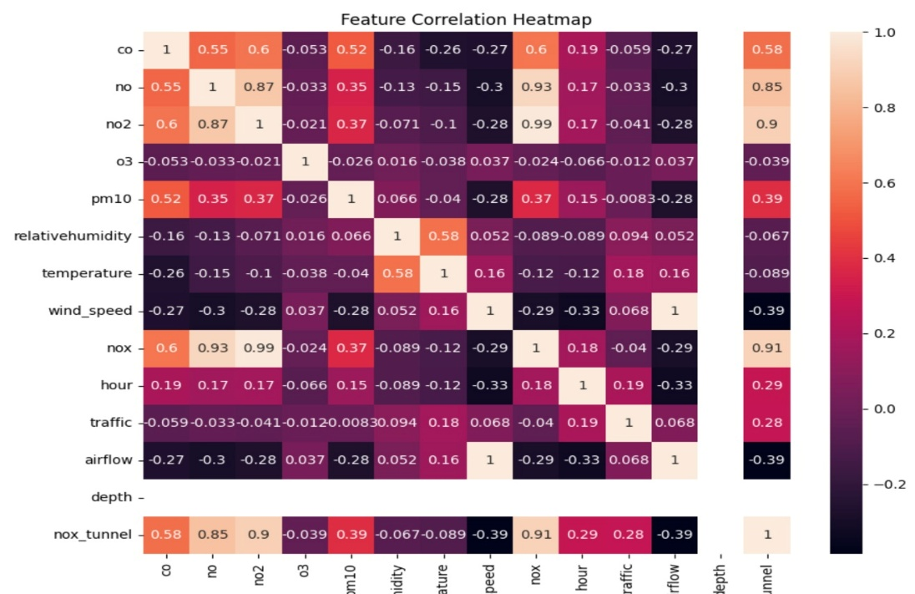
Figure 15: Feature Correlation Heatmap

- Discussion
The research presented in this study enables several important points for discussion regarding the prediction of NOx concentration in subway tunnel environments[2], [3], [4], [6], [7], [8], [12], [13], [15]:
• The selection of an appropriate machine learning model plays a crucial role in balancing prediction accuracy and generalization capability. While simpler models such as Linear and Polynomial Regression provide baseline understanding, they often fail to capture complex nonlinear relationships present in environmental systems[3], [13]. In contrast, the Random Forest model demonstrated superior performance by effectively handling nonlinear interactions among variables, while also maintaining robustness against overfitting when properly tuned[15].
• It is essential to identify and incorporate meaningful input variables for accurate prediction. In this study, a combination of real-world pollutant data (such as NO₂, CO, and PM₁₀) and meteorological parameters (temperature, humidity, wind speed) was used alongside physics-based features like airflow, traffic intensity, and tunnel depth. The results indicate that not all variables contribute equally; features such as airflow, NO₂ concentration, and traffic intensity have a significantly higher impact on NOx prediction[6], [8], [12]. Including irrelevant or redundant variables may increase model complexity without improving performance, and in some cases, can reduce generalization capability.
• The integration of physics-based parameters into machine learning models proves to be highly beneficial. Purely data-driven models often lack contextual understanding, whereas the inclusion of domain knowledge—such as airflow dynamics and emission sources—enhances both predictive accuracy and interpretability[8], [12]. This hybrid approach ensures that the model not only learns patterns from data but also aligns with real-world physical behaviour of pollutant dispersion in confined environments.
• The variability and quality of data significantly influence model performance. Although real-time data from sources like OpenAQ provide valuable insights, inconsistencies such as missing values, measurement noise, and temporal fluctuations can affect prediction reliability[2], [6]. Additionally, environmental conditions in subway systems may vary across locations and time periods, meaning that models trained on one dataset may not directly generalize to another without proper adaptation or retraining.
• External and unobserved factors may also impact NOx levels but are not explicitly captured in the dataset. For instance, factors such as tunnel design variations, ventilation system efficiency, train frequency, braking mechanisms, and passenger density can influence pollutant accumulation[7]. While some of these effects are indirectly reflected in variables like traffic intensity and airflow, a more detailed representation of such parameters could further improve model performance.
• The achieved performance of the Random Forest model, with a high R² score and low RMSE, indicates strong predictive capability. However, it is important to consider the presence of outliers and extreme conditions, which may appear as sudden spikes in pollutant levels[3], [13]. These anomalies can slightly reduce overall accuracy but represent real-world transient events. Handling such outliers through preprocessing or robust modelling techniques can further enhance prediction stability.
• The application of explainable AI techniques such as SHAP and LIME adds significant value to the study. These methods provide insights into feature importance and model decision-making, addressing one of the major limitations of black-box machine learning models[3], [15]. Understanding how different factors influence NOx levels is critical for practical implementation, as it supports informed decision-making for ventilation control and pollution mitigation strategies.
• While the results of this study are promising, further research is necessary to explore additional modelling approaches and improve scalability. Advanced techniques such as deep learning, hybrid physics-based simulations, or real-time adaptive models could be investigated to enhance prediction performance under dynamic conditions[12], [13]. Expanding the dataset across multiple subway stations and incorporating real-time sensor integration would also strengthen the applicability of the proposed framework[2], [6].
• Overall, this study demonstrates that combining physics-based insights with machine learning provides a practical and effective solution for NOx prediction in subway environments. The approach offers a scalable framework for real-time air quality monitoring and has the potential to support smarter urban infrastructure planning and public health protection[4], [8], [12].

- Conclusion
This study successfully developed a physics-informed machine learning framework for predicting NOx concentrations in subway tunnel environments[2], [4], [8], [12]. By integrating real-world air quality data with physics-based parameters such as airflow, traffic intensity, and tunnel characteristics, the proposed model achieves both high predictive accuracy and improved interpretability[6], [12]. The inclusion of domain-specific knowledge enables the model to better represent real-world pollutant behavior, making it more reliable compared to purely data-driven approaches[3], [13].
Among the evaluated models, the Random Forest algorithm demonstrated superior performance in capturing complex nonlinear relationships within the dataset[15]. Its ability to handle multicollinearity and varying feature importance makes it particularly suitable for environmental prediction tasks[7], [15]. The model’s high R² score and low error metrics indicate strong predictive capability, even under dynamic and fluctuating environmental conditions[3], [13].
The incorporation of explainable AI techniques such as SHAP and LIME further strengthens the reliability and transparency of the proposed framework[3], [15]. These methods provide clear insights into feature importance and model decision-making processes, allowing for better understanding of how different variables influence NOx levels. This interpretability is essential for real-world applications, as it supports informed decision-making for ventilation control, pollution mitigation, and urban environmental management[6], [12].
Furthermore, the proposed framework demonstrates strong potential for integration into real-time air quality monitoring systems within smart city infrastructure[2], [4], [8], [12]. By enabling continuous prediction and analysis, it can assist in optimizing ventilation strategies, enhancing commuter safety, and supporting data-driven policy formulation[6], [7]. The combination of physics-based modelling and machine learning thus provides a scalable and practical solution to address the growing challenge of underground air pollution[4], [8], [12].

- References
[1] S. Taha et al., “Comprehensive Review of Health Impacts of the Exposure to Nitrogen Oxides (NOx), Carbon Dioxide (CO2), and Particulate Matter (PM),” Journal of Hazardous Materials Advances, vol. 19, p. 100771, Jun. 2025, doi: 10.1016/j.hazadv.2025.100771.
[2] U. K. Lilhore et al., “Advanced air quality prediction using multimodal data and dynamic modeling techniques,” Sci Rep, vol. 15, no. 1, p. 27867, Jul. 2025, doi: 10.1038/s41598-025-11039-1.
[3] L. Naizabayeva, G. Sembina, and G. Tleuberdiyeva, “Hybrid Physics–Machine Learning Framework for Forecasting Urban Air Circulation and Pollution in Mountain–Valley Cities,” Applied Sciences, vol. 15, no. 22, p. 12315, Jan. 2025, doi: 10.3390/app152212315.
[4] N. Sarkar, P. Keserwani, and M. Govil, A Literature Survey: AQI Prediction Using ML, DL and Hybrid Models. 2024. doi: 10.21203/rs.3.rs-4924982/v1.
[5] W. Zhang, H. Zhao, A. Zhao, J. Lin, and R. Zhou, “Current Status, Challenges and Resilient Response to Air Pollution in Urban Subway,” Atmosphere, vol. 10, no. 8, p. 472, Aug. 2019, doi: 10.3390/atmos10080472.
[6] S.-H. Woo et al., “Investigation of Diurnal Pattern of Generation and Resuspension of Particles Induced by Moving Subway Trains in an Underground Tunnel,” Aerosol Air Qual. Res., vol. 18, no. 9, pp. 2240–2252, 2018, doi: 10.4209/aaqr.2017.11.0444.
[7] T. Moreno et al., “Subway platform air quality: Assessing the influences of tunnel ventilation, train piston effect and station design,” Atmospheric Environment, vol. 92, pp. 461–468, Aug. 2014, doi: 10.1016/j.atmosenv.2014.04.043.
[8] A. Banasiewicz, P. Śliwiński, P. Krot, J. Wodecki, and R. Zimroz, “Prediction of NOx Emission Based on Data of LHD On-Board Monitoring System in a Deep Underground Mine,” Energies, vol. 16, no. 5, p. 2149, Feb. 2023, doi: 10.3390/en16052149.
[9] M. Méndez, M. G. Merayo, and M. Núñez, “Machine learning algorithms to forecast air quality: a survey,” Artif Intell Rev, vol. 56, no. 9, pp. 10031–10066, Sep. 2023, doi: 10.1007/s10462-023-10424-4.
[10] K. J. Ryu, “Ventilation Efficiency in the Subway Environment for the Indoor Air Quality,” vol. 6, no. 3, 2012.
[11] M. N. Smirnova, V. F. Nikitin, D. A. Pestov, and Z. Zhu, “Mathematical modeling of air pollution in city tunnels and evaluating mitigation strategies,” Transportation Research Interdisciplinary Perspectives, vol. 4, p. 100086, Mar. 2020, doi: 10.1016/j.trip.2019.100086.
[12] S. Wang et al., “Indoor air quality in subway microenvironments: Pollutant characteristics, adverse health impacts, and population inequity,” Environment International, vol. 190, p. 108873, Aug. 2024, doi: 10.1016/j.envint.2024.108873.
[13] M. Karmoude et al., “Machine learning for air quality prediction and data analysis: Review on recent advancements, challenges, and outlooks,” Science of The Total Environment, vol. 1002, p. 180593, Nov. 2025, doi: 10.1016/j.scitotenv.2025.180593.
[14] I. E. Agbehadji and I. C. Obagbuwa, “Systematic Review of Machine Learning and Deep Learning Techniques for Spatiotemporal Air Quality Prediction,” Atmosphere, vol. 15, no. 11, p. 1352, Nov. 2024, doi: 10.3390/atmos15111352.
[15] L. B. Peinado, T. Guarda, G. Herrera-Vidal, C. Minnaard, and J. R. Coronado-Hernández, “Statistical and Machine Learning Models for Air Quality: A Systematic Review of Methods and Challenges,” Algorithms, vol. 18, no. 12, p. 783, Dec. 2025, doi: 10.3390/a18120783.
[16] “OpenAQ Homepage.” Accessed: Mar. 28, 2026. [Online]. Available: https://openaq.org/
[17] “Use Cases.” Accessed: Mar. 28, 2026. [Online]. Available: https://openaq.org/about/use-cases/?utm_source=chatgpt.com

